

A

PROJECT REPORT ON

**“CROP RECOMMENDATION SYSTEM USING MACHINE LEARNING”**

SUBMITTED TO THE SAVITRIBAI PHULE PUNE UNIVERSITY, PUNE IN THE PARTIAL FULFILLMENT FOR THE AWARD OF THE DEGREE

**OF**

**BACHELOR OF ENGINEERING**

**IN**

**INSTRUMENTATION**

BY

**JOGDAND ANAND BALASAHEB (72023892H)**

**ZAGADE SHRUTI SANJAY (72024195C)**

**JAGDHANE VAISHNAVI RAJENDRA (72023885E)**

UNDER THE GUIDANCE OF

GUIDED BY

**Dr. V. V. KALE.**

Department Of Instrumentation Engineering



**AISSMS INSTITUTE OF INFORMATION TECHNOLOGY, PUNE**

**ACADEMIC YEAR 2022-2023**



**DEPARTMENT OF INSTRUMENTATION ENGINEERING**

**CERTIFICATE**

This is to certify that Project Report entitled

**“CROP RECOMMENDATION SYSTEM USING MACHINE LEARNING”**

Submitted by

**JOGDAND ANAND BALASAHEB (72023892H)**

**ZAGADE SHRUTI SANJAY (72024195C)**

**JAGDHANE VAISHNAVI RAJENDRA (72023885E)**

Is a bonafide work carried out by them under the supervision of Dr. V.V.KALE and it is approved for the partial fulfillment of the requirements of Savitribai Phule Pune University, for the award of the degree of Bachelor of Engineering (Instrumentation), in Academic Year 2022-23.

This project has not been earlier submitted to any other or university for the award of any degree or diploma.

|  |
| --- |
| (Dr. Mrs. .V.V.KALE**) (**Dr. Mrs. .A.A.SHINDE)  **HOD**  **Instrumentation Engineering**  **PROJECT GUIDE**  **Instrumentation Engineering**    (Dr. P.B.MANE)  **PRINCIPAL**  **AISSMS IOIT, PUNE**  i |

**ABSTRACT**

Agriculture is the main field of employment in India. Farmers are faced with many problems to evaluate the yield of the crops. The production of crops plays an important role in our Indian Economy. This proposed system helps the farmers to choose suitable crop based on rainfall, humidity, type of soil etc. It will help the farmers by reducing the loss faced by them and improve yield. Farmers are unable to select the right crop by using manual prediction. The process of manual prediction may result in failure. Accurate crop prediction results in increase crop cultivation. This is where machine learning playing an important role in the area of crop cultivation. Thus we proposed crop recommendation using machine learning techniques such as k-nearest (KNN) and Random Forest. Both models are simulated comprehensively on Indian data set**.** This model will help farmers to know the type of the crop before cultivating onto the agricultural field and thus help them to make appropriate decisions

ii

**INDEX**

|  |  |  |
| --- | --- | --- |
| CHAPTER N0. | TOPIC | PAGE NO. |
|  | CERTIFICATE | I |
|  | ABSTRACT | II |
|  | INDEX | III |
|  | ACKNOWLEDGEMENT | IV |
|  | LIST OF FIGURES | V |
|  | LIST OF TABLES | VI |
| 1 | INTRODUCTION | 1 |
| 1.1 | PROBLEM STATEMENT | 2 |
| 1.2 | OBJECTIVES | 2 |
| 2 | LITERATURE SURVEY | 3 – 5 |
| 2.2 | LITERATURE SUMMARY | 6 |
| 3 | SOFTWARE REQUIREMENT SPECIFICATION | 7 |
| 3.1 | PROJECT SCOPE | 7 |
| 3.2 | ASSUMPTIONS AND DEPENDENCIES | 7 |
| 3.3 | FUNCTIONAL REQUIREMENTS | 7 |
| 4 | SYSTEM DESIGN | 8 |
| 4.1 | DATA FLOW DIAGRAM | 8-16 |
| 5 | PROJECT IMPLEMETATION PLAN | 17 |
| 6 | SOFTWARE TESTING | 18 |
| 6.1 | RANDOM FOREST | 19 |
| 6. | K-NEAREST NEIGHBOUR | 20 |
| 7 | RESULTS | 21 |
| 8 | CONCLUSION | 22 |
| 9 | REFERENECES | 23 |

iii

**ACKNOWLEDGEMENT**

Inspiration and guidance are invaluable in every aspect of the life, especially in the field of the academics, which I have received from my respected project guide **Dr. Mrs. V. V. KALE.** I would like to thank her as she was responsible for the complete project and also for his endless contribution of time, efforts, valuable guidance and encouragement he has given to me. I would like to extend my thanks to respected HOD **Dr. Mrs. A. A. SHINDE** for her constant support and motivation. I would also like to thank respected Principal, **Dr. P.B. MANE** without whom we would not have opportunity to reach up to this level. I would also thank my colleagues, my Parents and friends for their inspiration and motivation and those who helped me directly or indirectly for my project work.

.

iv

**LIST OF FIGURE**

|  |  |  |
| --- | --- | --- |
| FIG NO. | FIGURE NAME | PAGE NO. |
| 1 | SYSTEM ARCHITECTURE | 8 |
| 2 | DATASET SNAPSHOT | 9 |
| 3 | CORRELATION PLOT | 11 |
| 4 | DISTRIBUTION OF CROPS ACCORDING TO PARAMETER | 12 |
| 5 | DISTRIBUTION OF INDIVIDUAL CROPS WITHIN EACH PARAMETER | 13 |
| 6 | CROP DATA PAIR PLOT | 14 |
| 7 | KNN | 15 |
| 8 | RANDOM FOREST | 16 |
| 9 | GUI | 16 |
| 10 | RANDOM FOREST HEATMAP | 18 |
| 11 | HEATMAP KNN | 19 |
| 12 | ACCURACY REPORT KNN | 20 |
| 13 | CROP RECOMMENDATION SYSTEM FINAL OUTPUT | 21 |

v

**LIST OF TABLES**

|  |  |  |
| --- | --- | --- |
| SR.NO | FIGURE NAME | PAGE NO. |
| 1 | LABEL ENCODING | 10 |
| 2 | IMPLEMENTATION PLAN | 17 |
| 3 | ACCURACY TRANDOM FOREST | 19 |
| 4 | ACCURACY KNN | 20 |
| 5 | COMPARISON BETWEEN RF AND KNN ACCURACY | 21 |

vi

**CHAPTER 1**

**INTRODUCTION**

Modern techniques are now being used and put into practice by other countries for financial gain. One can only imagine how much of an advantage they already have when it comes to using scientific and technology ways to improve agriculture and farming. India, on the other hand, continues to use farming's conventional methods and technologies.

As we all know, a significant portion of our nation's income comes from agriculture alone. When discussing the Gross Domestic Product value, the income come is quite useful. As we get closer to globalization, the need for food has multiplied. Farmers use various artificial fertilizers to try to enhance the amount of their production, but this practice eventually harms the ecosystem. However, if the farmer is aware of the precise crop to plant in response to various soil types and environmental factors, this will reduce loss and lead to effective crop production. We have compiled a dataset that includes data on rainfall, meteorological conditions, and various soil nutrients. Input characteristics such as nitrogen (N), phosphorus (P), potassium (K), soil PH, humidity, temperature, and rainfall are used in this paper to suggest the best crop. The most appropriate crop is suggested based on the accuracy of the future production of eleven different crops, including rice, maize, chickpeas, kidney beans, pigeon peas, moth beans, moonbeams, black gram me, lentil, pomegranate, banana, mango, grapes, watermelon, muskmelon, apples, oranges, papayas, coconuts, cotton, jute, and coffee. The dataset includes a number of factors, including humidity, temperature, rainfall, nitrogen (N), phosphorus (P), potassium (K), and soil PH. Different machine learning techniques, including Decision Trees, Naive Bayes (NB), and Support Vector Machine, were used in the suggested system (SVM), Random Forest (RF).This will help us better understand agricultural production patterns when taking regional and environmental aspects into account. Additionally, our approach foresees the dearth of any specific inputs needed to develop a certain crop. The agricultural industry might greatly benefit from our predictive method. With the aid of our predictive technology, the issue of nutrient deficiency in certain areas—caused by the reason of planting the improper crop at the wrong time is eliminated. Farmers' production efficiency decreases as a result. Agriculture will undoubtedly advance to new heights as more and more science is applied to it.

1

We suggest this technique to educate farmers on the needs for various minerals and the climatic conditions that are ideal for growing particular crops. Additionally, our study refocuses our attention on the paucity of various minerals needed to cultivate some crops and suggests solutions to end their scarcity. Our approach takes into account elements Like the makeup of the soil and environmental variables like temperature, rainfall, and humidity.

**1.1 PROBLEM STATEMENT**

To develop a recommendation system using machine learning for crop growth by taking all the factors like rainfall and soil type to build a simpler mechanism to predict the crops that are suitable to be grown in that soil.

* 1. **OBJECTIVES**

Predict suitable crop to assist farmers in growing a better variety of crop based on soil parameters.

2

**CHAPTER 2**

**LITERATURE SURVEY**

Dr. Y. Jeevan Nagendra Kumar [1] It gives us an idea for the finest predicted crop which will be cultivate in the field weather conditions. These predictions can be done by a machine learning algorithm called Random Forest. It will attain the crop prediction with best accurate value. The algorithm random forest is used to give the best crop yield model by considering least number of models. It is very useful to predict the yield of the crop in agriculture sector.

Mr A Suresh, [2] "Prediction of major crop yields of Tamilnadu," The aim of this paper is to predict the yield of the crop using the KNN algorithm based on existing data. For the construction of the models, real data from Tamil Nadu was used and the models were checked using samples. To accurately predict crop yield, the KNN Algorithm can be used.

Ajay Lokhande, [3]"Crop Recommendation System Using Machine Learning," analysed the many Machine Learning techniques used to predict soil type, soil moisture, and soil nutrients. SVM, naive Bayes, Random Forest, and Decision Trees are a few examples of machine learning algorithms in use . Despite the fact that many algorithms were described, the emphasis remained on picking the optimal algorithm to apply. With an accuracy of 96%, random forest is more accurate than DT and gave the highest accurate value when compared to SVM.

Doshi, Zeel, Subhash Nadkarni, Rashi Agrawal, and Neepa Shah. [4] “AgroConsultant: Intelligent Crop Recommendation System Using Machine Learning Algorithms”. Supervised Machine Learning methods were used to analyse a set of data in order to make the prediction.The main algorithms employed were decision tree learning, K-Nearest Neighbors Regression, and random forest algorithms. But, just a few datasets were used for training. the suggested system's accuracy for Decision tree, KNN, and Random forest was 90.20%, 89%, and 90.43% respectively.

Dr. V.Geetha, [5]"An Effective Crop Prediction Using Random Forest," A describes the important work done by data mining techniques in the agricultural sector. They have incorporated the unique ML calculations, such as KNN, SVM, RF, and others. The harvests were mostly predicted based on climate features, giving an accuracy score of roughly 95%.

Mullangi Ramu, [6] "Wheat yield prediction using AI model," They studied and analyzed which algorithm would be suitable for which crop. KNN, SVM, Random Forest, neural networks, decision trees, etc. have all been employed.

3

The underlying factors were soil nutrients like N, K, and P as well as soil ph. Compared to neural networks, random forest performs significantly better.

S. M. PANDE, P. K. RAMESH, A. ANMOL, B. R. AISHWARYA, K. ROHILLA and K. SHAURYA, "Crop Recommender System Using Machine Learning Approach," [7] proposes a viable and user friendly yield prediction system for farmers in which Machine Learning algorithms such as SVM, MLR, RF etc. Among them, the Random Forest showed the best result with 95% accuracy.

D. Modi, A. V. Sutagundar, V. Yalavigi and A. Aravatagimath, [8]"Crop Recommendation Using Machine Learning Algorithm," this proposed work present SVM algorithm based crop recommendation system for the farmers. The SVM algorithm is considered for classification to test the effectiveness of the proposed algorithm accuracy and confusion matrix are computed.

A. Motwani, P. Patil, V. Nagaria, S. Verma and S. Ghane, [9] "Soil Analysis and Crop Recommendation using Machine Learning," this paper proposes a crop recommendation system that uses a CNN and Random Forest model to predict the optimal crop to be grown. The CNN architecture gave an accuracy of 95.21% and Random Forest Algorithm had an accuracy of 75%.

G. Chauhan and A. Chaudhary, [10] "Crop Recommendation System using Machine Learning Algorithms, "This paper represents the utilization of machine learning approaches like Random Forest and Decision Tree to predict which crop is best for which soil type based on the data sets.

R. K. Ray, S. K. Das and S. Chakravarty, [11] "Smart Crop Recommender System-A Machine Learning Approach”, this article uses ensembling with base learners i.e., Decision Tree , Naïve Bayes, RF and SVM.

Namgiri Suresh, N.V.K.Ramesh, Syed Inthiyaz, P. Poorna Priya, Kurra Nagasowmika, V.N.Harish Kumar, Mashkoor Shaik and N. K. Reddy [12]in this article crop yield prediction is done by using random forest algorithm. Here data collected from online source and RF gave an accuracy 75%.

E. Esakki Vigneswaran, M. Selvaganesh [13] “Decision Support System for Crop Rotation Using Machine Learning” This described to help farmers determine the quality of soil by measuring the amount of Urea, potassium, magnesium, pH, and Nitrogen using a Neuro-Fuzzy based machine learning algorithm. The result yields the effective crop rotation sequence with an accuracy 80%.

.

4

**2.1 RELATED WORK**

|  |  |  |  |  |
| --- | --- | --- | --- | --- |
| **Paper** | **Datasets** | **Methodology** | **Accuracy** | **References** |
| IEEE (June 2021) | Online source | Random forest(RF) | RF = 75% | [12] |
| IEEE(May 2021) | GitHub | Random forest(RF), and Artificial Neural Network(ANN) | RF works much better than ANN | [6] |
| IEEE(May 2021) | Online source | Random forest(RF) | RF = 95% | [5] |
| IEEE(2020) | Kaggle website | Decision Trees(DT), Random forest(RF) | RF is more accurate than DT | [1] |
| IEEE (2018) | various government departments of Tamil Nādu | K Nearest Neighbor (KNN) | KNN = 96% | [2] |
| IEEE(2020) | agriculture field | Neuro-Fuzzy | Neuro-Fuzzy = 80% | [13] |
| IRJET (2022 ) | Kaggle website | Random forest(RF), Decision Trees(DT), Support Vector Machine (SVM) | RF = 96%  RF is more accurate than DT and DT much batter than SVM | [3] |
| IEEE(2018) | India Agriculture and Climate Data Set | Random forest(RF), Decision Trees(DT), K Nearest Neighbor (KNN) | DT = 90.20%  K-NN = 89.78  RF = 90.43 | [4] |
| IEEE(2021) |  | Random forest(RF), Support Vector Machine (SVM), MLR | RF = 95% | [7] |
| IEEE(2021) |  | Support Vector Machine (SVM) |  | [8] |
| IEEE(2022) | ( Image dataset) | CNN, Random Forest | CNN = 95%  RF = 75% | [9] |
| IEEE(2021) |  | Decision Trees(DT), Random forest(RF) |  | [10] |
| IEEE(2022) |  | NaïveBayes,DecisionTrees(DT), Random forest(RF), SVM. |  | [11] |

5

**2.2 SUMMURY OF LITERATURE SURVEY:**

The current systems which employ various machine learning methods, are useful and accurate when employed for their respective regions. As [2] this model is useful for the Tamil Nadu region. It is noted that in some existing recommendation models Environmental conditions used as primary input [1] and in some soil properties are predominantly used as input for predicting crops [13]. To obtain best accuracy comparative study of different algorithms are done in existing models like Random Forest[9][10][11][7][3][12][6][4] in which [3] have high accuracy, K-Nearest Neighbor[4],Support Vector Machine[3], Decision Tree [4][3][1], Neuro Fuzzy [12] etc. Climate and soil characteristics are the input parameters for our proposed system. To suggest best crop in order to increase agricultural output for local farmers. Additionally, compared to our work, existing systems accuracy is poor. The proposed approach offers greater accuracy in KNN and Random forest.

6

**CHAPTER 3**

**SOFTWARE REQUIREMENT SPECIFICATION**

**3.1 PROJECT SCOPE**

Crop yields and crop yield forecasts directly affect the annual national and international economy and play a major role in the food economy. Crop yields are highly dependent on irrigation and climate data. More irrigation does not necessarily increase yield, and therefore, optimization of irrigation and more efficient irrigation systems are critical. Predicting yield based on different types of irrigation is one way to optimize the process.

**3.2 ASSUMPTIONS AND DEPENDENCIES**

Assumptions: We have used Python Technique. Input as Soil types Dataset and Weather. Dependencies: We have used python libraries like Tensorflow, keras, and Tkinter, matplotlib, pandas, numpy, sklearn Output to detect Soil Type and Suggest Crop.

* 1. **SOFTWEAR REQUIREMENTS**
* Operating System : 64 bit Windows10
* Coding language: Python
* IDE : Jupyter
* Python Libraries : Tensorflow, keras , Matplotib
* Database : DBSqlite3

7

**CHAPTER 4**

**SYSTEM DESIGN**

**4.1 DATA FLOW DIAGRAM**

***Predictive Model***

***1) K Nearest Neighbor (KNN)***

***2) Random forest (RF)***

***Input Dataset***

***Pre-Processing***

***GUI***

Fig.1-System Architecture

The most important stages in the construction of a machine learning-based crop recommendation model are shown in the following Steps:

**4.1.1 DATA COLLECTION:**

The initial phase of machine learning project development is data collection. The dataset we get from different platforms is raw data with a many mistakes and ambiguities. In this project we have collected our data from an open source platform known to as Kaggle [14] . Our dataset is basically a collection of two more complex data sets.

**a) Soil content dataset**: (consisting information about ratios of Nitrogen (N), Phosphorous (P) and Potassium (K) and ph. Of the soil)

**b) Climatic condition dataset:** (containing information about rainfall, humidity and temperature).

8

Crop data is stored in excel file contain data for 22 different types of crops with 2200 samples & seven features this data will be used to train our model.

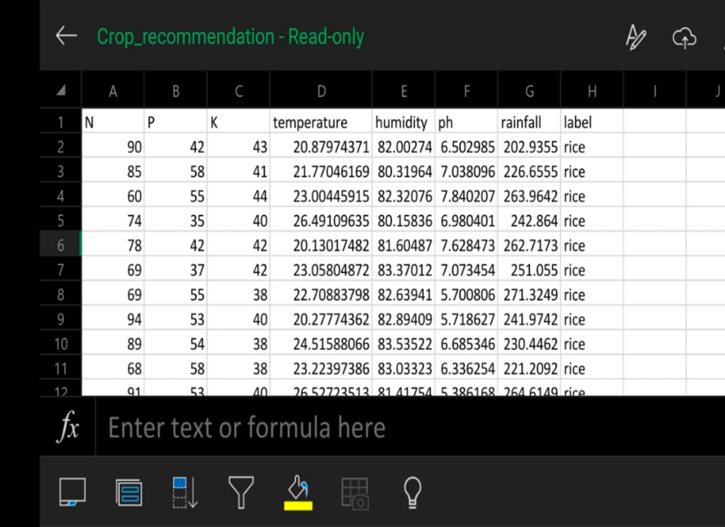

Fig.2-Dataset snapshot

9

**4.1.2 DATA PREPROSSING:**

After collecting data for our machine learning model, we performed pre-processing on our dataset. There are multiple methods for preprocessing, but we are preferring to go with label encoding as we have the 22 crop types in string format, which needs to be converted into numeric form to be understood by the computer.

1. **LABEL ENCODING**:

It converts the string format into the numeric format. As compared with our dataset, there are 22 different crop types, and it gives a number to every crop type in alphabetical order of crop names.

|  |  |
| --- | --- |
| **CROP TYPE** | **LABEL ENCODING** |
| Rice | 20 |
| Maize | 11 |
| Chickpea | 3 |
| kidney beans | 9 |
| Pigenbeans | 18 |
| Mothbeans | 13 |
| Mung beans | 14 |
| Black gram | 2 |
| Lentil | 12 |
| Pomegranate | 19 |
| Banana | 1 |
| Mango | 12 |
| Grapes | 7 |
| Watermelon | 21 |
| Muskmelon | 15 |
| Apple | 6 |
| Orange | 16 |
| Papaya | 17 |
| Coconut | 4 |
| coffee | 5 |

Table 1-label encoding

1. **EXPLORATORY VISUAL 1: CORRELATION PLOT**

* Phosphate (P) and potassium (K) values are highly correlated to one another.

Individually P and K will contribute similar levels of variance to the model

* Our crops ‘label’ target vector is most correlated to humidity and least correlated to Ph. Humidity will have a large effect on our model while Ph may have negligible affect

Fig5-Correlation plot

Fig.3- Correlation plot

11

**4.1.3 TRAINING AND TESTING:**

To understand model performance, dividing the dataset into a training set and a test set is a good strategy. Let’s split dataset by using function train_test_split (). You need to pass 3 parameters features, target, and test_set size. Additionally, you can use random state to select records randomly. Here we are taking training data 80% and testing data 20% from existing dataset.

**4.1.4 PREDICTIVE MODEL:**

Choosing the perfect algorithm for a crop dataset is a difficult task. To solve this problem we have plotted a pair plot using the Seaborn library. The data appears to be too overlapping, according to the data visualizations. In this scenario, we can use algorithms like decision trees, random forests, SVM, and KNN. First, we are attempting to determine the accuracy of KNN and Random Forest. KNN and Random Forest provide higher accuracy, so we implemented KNN and RF for our model.

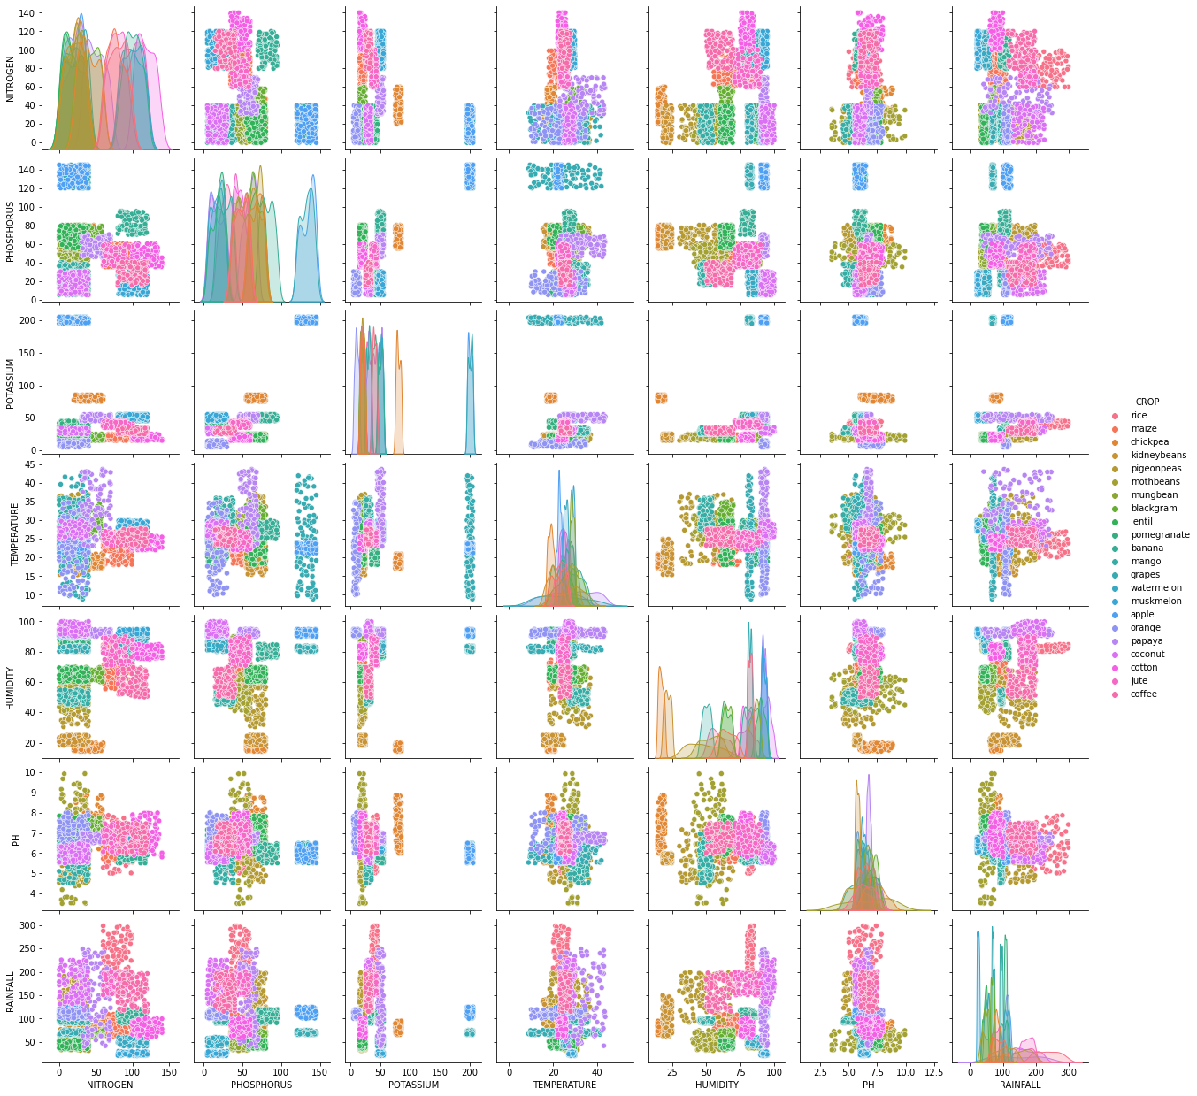

Fig.4- crop data pair plot

12

The detailed explanation of algorithms as follows:

**1) KNN**

K-Nearest Neighbor is one of the simple machine learning algorithms based on supervised learning. K-NN assumes identical entities between the new case and available case and put new one into the category that is most identical to available categories. K-NN algorithm stores all the available data and evaluates a new data point based on similarity. This means when new data appears then it can be easily classified into well suite category by using K-NN algorithm. Here we consider parameters like humidity, rainfall, soil type, area etc. We have assigned rainfall, soil type as input parameters although other parameters may also be considered. The crop yield which is an unknown value can be predicted using the values of the nearest known neighbors. This is possible by calculation Euclidian distance between those points. Thus we will be able to predict crop for the given input parameters. The calculation of distance between points in a feature space, different distance functions could be used, in which the Euclidean distance function is the most commonly used one. Say p and q are represented as feature vectors. To measure the distance between p and q, the Euclidean metric is generally used by if a = (a1, a2) and b = (b1, b2) then the distance is given by:

D (a, b) =

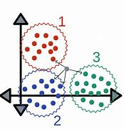

Fig.5 - KNN

13

**2) RANDOM FOREST:**

Random forest algorithm is a popular algorithm for machine learning. This machine learning algorithm belongs to the supervised learning system. It is based on random forest algorithm principle. Presence of excessive random trees in a random forest network, leads to high accuracy of model. It finalize the decision from the tree with most votes. Hence, excessive the number of decision tree in forest more the accuracy of model.

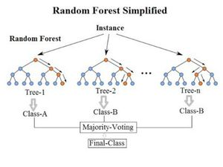

Fig.6-Random Forest

**4.1.5 GRAPHICAL USER INTERFACE:**

On this crop recommendation system interface a farmer has to be enter all the necessary details related to farming like ratio of nitrogen in the soil ratio of phosphorus in the soil ratio ph. , these all information are very important for our model to predict which crop will be the best for the farmer to grow at the backend of GUI we have connected our machine learning model and database to the GUI.

Python libraries used: pyttx3, PySimpleGUI, pillow(adding images to GUI)

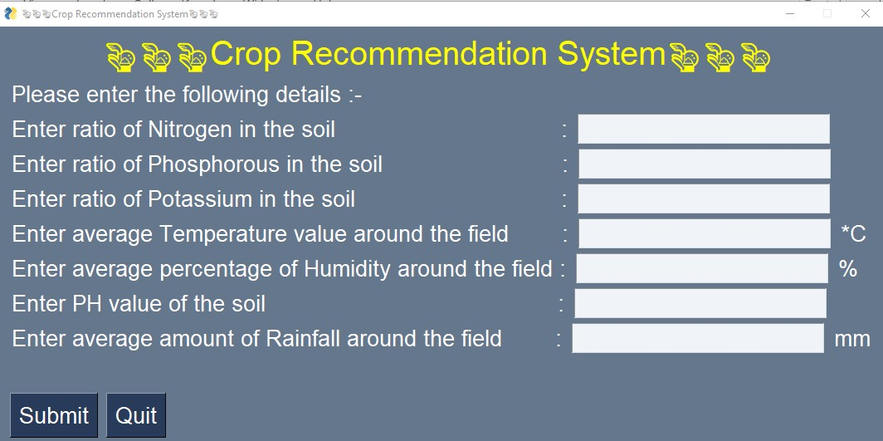

Fig 7: GUI

14

**CHAPTER 5**

**SYSTEM IMPLEMENTATION PLAN**

|  |  |  |  |
| --- | --- | --- | --- |
| Sr. No. | Name/Title | Start Date | End Date |
| 1 | Preliminary Survey |  |  |
| 2 | Introduction and Problem Statement |  |  |
| 3 | Literature Survey |  |  |
| 4 | Project Statement |  |  |
| 5 | Software Requirement And Specification |  |  |
| 6 | System Design |  |  |
| 7 | Partial Report Submission |  |  |
| 8 | Architecture Design |  |  |
| 9 | Implementation |  |  |
| 10 | Deployment |  | - |
| 11 | Testing |  |  |
| 12 | Paper Publish |  | - |
| 13 | Report Submission |  |  |

The System Implementation plan table, shows the overall schedule of tasks compilation and time duration required for each task.

Table 2- Implementation plan

15

**CHAPTER 6**

**SOFTWARE TESING**

Our Crop recommendation system is a kind of classification problem, we have trained and tested a number of algorithms to solve this problem. We prioritized accuracy for best accuracy and planting the best crops. We compared the accuracy of all models and determined who has the highest accuracy.

We have used here cross validation training method is a validating technique that is used to verify how the arithmetic model derived to a datasets. Here, we have used here K- folding cross validation. In this type of cross validation we only use about 1 set of data to train, and other else are used for training our model. Also our crop recommendation system project is a combination of all the functional units of the program developed separately. Here, in this project we have tried and tested machine learning algorithms random forest, knn in order to obtain a good and accuracy model for farmers to predict crops. All the models are tested for the attributes such as accuracy.

**6.1 RANDOM FOREST**

Random forest algorithm is a popular algorithm for machine learning. This machine learning algorithm belongs to the supervised learning system. It is based on random forest algorithm principle. The accuracy of random forest here we use cross validation technique to check the accuracy of the random forest model the accuracy table is given below:

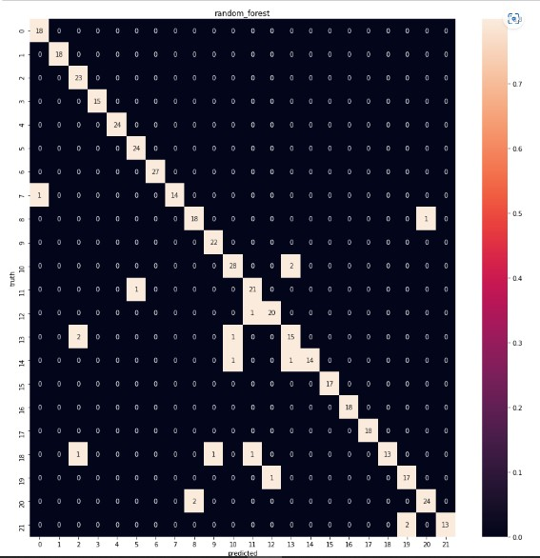

Table 2-random forest accuracy table

Fig.8-Random forest heatmap

16

|  |  |  |  |
| --- | --- | --- | --- |
| TRAINING_DATA | TESTING_DATA | N_ESTIMATOR | ACCURACY |
| 20% | 80% | 1 | 95.6% |
| 20% | 80% | 2 | 95.9% |
| 20% | 80% | 3 | 99.3% |
| 20% | 80% | 4 | 98.1% |
| 20% | 80% | 8 | 99.3% |
| 20% | 80% | 9 | 99.3% |
| 20% | 80% | 10 | 99.5% |
| 30% | 70% | 1 | 99.5% |
| 30% | 70% | 2 | 96.3% |
| 30% | 70% | 3 | 94.8% |
| 30% | 70% | 4 | 98.3% |
| 30% | 70% | 5 | 99% |
| 30% | 70% | 6 | 99% |

Table 3- random forest accuracy

**6.2 K-NEAREST NEIGHBOR**

K-Nearest Neighbor is one of the simple machine learning algorithms based on supervised learning. K-NN assumes identical entities between the new case and available case and put new one into the category that is most identical to available categories...

Here calculate the distance between each data point and cluster center (centroid) using the Euclidian formula:

Distance =

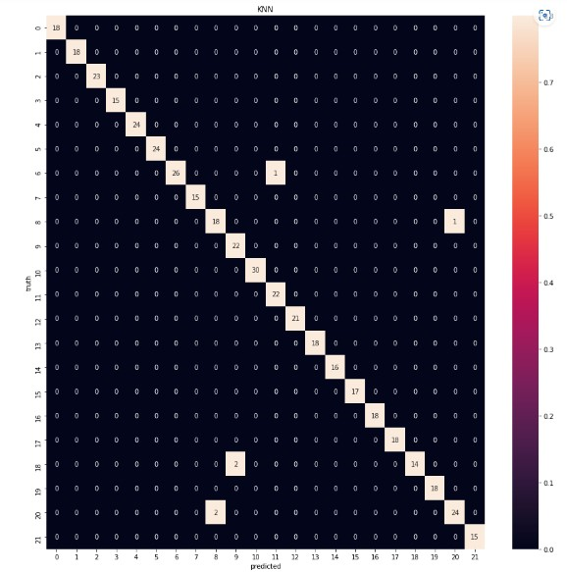

Fig 9 –Heat map knn

17

|  |  |  |  |
| --- | --- | --- | --- |
| TESTING_DATA | TRAINING_DATA | K Estimator | ACCURACY |
| 20% | 80% | 1 | 96.8% |
| 20% | 80% | 2 | 97.5% |
| 20% | 80% | 3 | 97.9% |
| 20% | 80% | 4 | 97.7% |
| 20% | 80% | 5 | 98% |
| 20% | 80% | 10 | 97.73% |
| 20% | 80% | 15 | 96.8% |
| 20% | 80% | 6 | 98.4% |
| 20% | 80% | 7 | 97.9% |
| 30% | 70% | 1 | 97.4% |
| 30% | 70% | 2 | 97.8% |
| 30% | 70% | 3 | 98.3% |
| 30% | 70% | 4 | 97.2% |
| 30% | 70% | 5 | 98% |
| 30% | 70% | 10 | 97.7% |
| 30% | 70% | 15 | 97.8% |
| 30% | 70% | 20 | 97.7% |
| 30% | 70% | 5 | 97.8% |
| 30% | 70% | 6 | 98.3% |

Table .4-KNN Accuracy

18

**CHAPTER 7**

**RESULTS**

This proposed system recommends the foremost crop for particular area by considering parameters such as temperature, ph., potassium, Humidity etc. By entering data of these parameters user are able to predict accurate crop for their field. In the output section the system displays a suitable crop required. In this proposed model there is a speech module also developed by using python programming. This model reads the value entered by user and accurately predicted crop name.It has accuracy of KNN model 98% and random forest 98%.

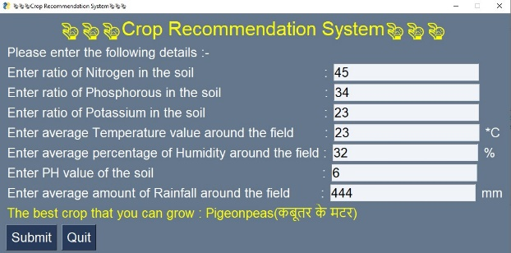 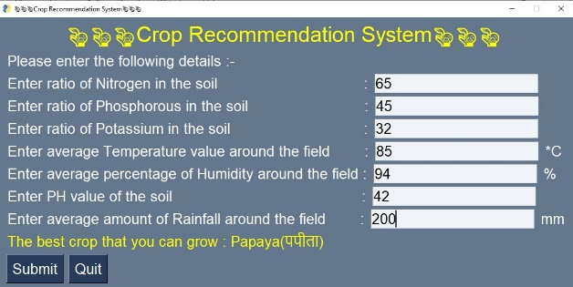

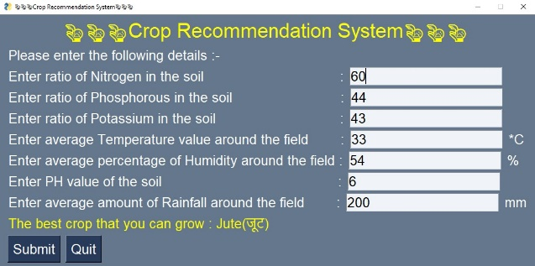 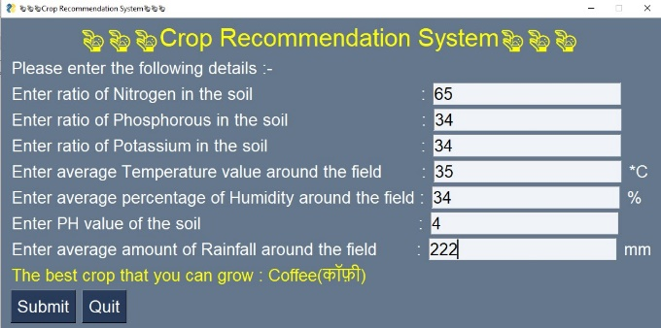

Fig.10- Crop Recommendation System final output

19

**CONCLUSION**

Agriculture is one of the important sector to the economy of our nation. Even the smallest investment made in this industry has a huge impact on our nation as a whole. Consequently, we must be more committed to it. Farmers in our nation frequently struggle to choose the best crops to plant since there is a lack of scientific understanding of the various aspects affecting crops. As a result of their lower output, they suffer a loss in earnings. The crop recommendation system suggest best crop to the farmer by using soil parameters like N,P,K, pH, rainfall, humidity, temperature. This system built by using two algorithms Random forest ,K-NN). However, our system will give them a glimmer of hope that they can cultivate crops that will bring in the maximum money. This system gives accuracy of 98%. Both the amount and the quality of their output will exponentially grow.

|  |  |
| --- | --- |
|  |  |

20

# REFERENCES

|  |  |
| --- | --- |
| [1] | V. S. Dr. Y. Jeevan Nagendra Kumar, "Supervised Machine learning Approach for," in Proceedings of the Fifth International Conference on Communication and Electronics Systems (ICCES 2020), IEEE 2020. |
| [2] | D. P. G. K. D. Mr A Suresh, "Prediction of major crop yields of Tamilnadu," in Proceedings of the International Conference on Communication and Electronics Systems (ICCES 2018), IEEE (2018). |
| [3] | P. M. D. Ajay Lokhande, "Crop Recommendation System Using Machine Learning," in International Research Journal of Engineering and Technology (IRJET) , 2022. |
| [4] | S. R. A. N. S. Zeel Doshi, "AgroConsultant: Intelligent Crop Recommendation System Using Machine Learning Algorithms," in (ICCUBEA), IEEE 2018. |
| [5] | A. P. M. A. M. A. A. Dr. V.Geetha, "An Effective Crop Prediction Using Random Forest," IEEE(2021). |
| [6] | J. T. S. Mullangi Ramu, "Wheat yield prediction using AI model," in International Conference on Advanced Computing & Inovative Technologices in Enginnering (ICACITE), IEEE May 2021. |
| [7] | P. K. R. A. A. B. R. A. K. R. a. K. S. S. M. PANDE, "Crop Recommender System Using Machine Learning Approach," in 5th International Conference on Computing Methodologies and Communication (ICCMC), 2021. |
| [8] | A. V. S. V. Y. a. A. A. D. Modi, "Crop Recommendation Using Machine Learning Algorithm," in 5th International Conference on Information Systems and Computer Networks (ISCON), 2021. |
| [9] | P. P. V. N. S. V. a. S. G. A. Motwani, "Soil Analysis and Crop Recommendation using Machine Learning," in International Conference for Advancement in Technology (ICONAT), 2022,. |
| [10] | G. C. a. A. Chaudhary, "Crop Recommendation System using Machine Learning Algorithms," in 10th International Conference on System Modeling & Advancement in Research Trends (SMART), 2021,. |
| [11] | S. K. D. a. S. C. R. K. Ray, "Smart Crop Recommender System-A Machine Learning Approach," in 12th International Conference on Cloud Computing, Data Science & Engineering (Confluence), 2022. |
| [12] | N. S. I. Namgiri Suresh, "Crop Yield Prediction Using Random Forest," in 7th International Conference on Advanced Computing & Communication Systems (ICACCS) 2021. |
| [13] | E. E. Vigneswaran, "Decision Support System for Crop Rotation Using ML," in IEEE 2020. |
| [14] | "https://www.kaggle.com/datasets/atharvaingle/crop-recommendation-dataset". |
|  |  |
|  |  |
|  |  |
|  |  |
|  |  |
|  |  |
|  |  |
|  |  |
|  |  |
|  |  |
|  |  |
|  |  |

21